English version is derived from the [x264](https://www.nazorip.site/archives/63) x265 Ultimate Tutorial Project by same author iAvoe

|  |  |
| --- | --- |
| [**LigH**](http://www.mediafire.com/?6lfp2jlygogwa) | .hevc GCC10 [single .exe 8-10-12bit] w/ x86 w/ libx265.dll |
| [**Rigaya**](https://drive.google.com/drive/u/0/folders/0BzA4dIFteM2dWEpvWGZXV3ZhdTA) | .hevc GCC 9.3 [8-10-12bit] w/ x86 |
| [**Patman**](http://www.mediafire.com/folder/arv5xmdqyiczc) | .hevc GCC 11+MSVC1925 [8-10-12bit] |
| [**ShortKatz**](https://forum.doom9.org/showthread.php?p=1937773#post1937773) | arm64~64e with x86 ? [?] macOS compiling needed |
| **[DJATOM-aMod](https://github.com/DJATOM/x265-aMod/releases/)** | Intel, AMD zen1~2 [10bit], zen3 [10-12bit] GCC 10.2.1+GCC10.3 |
| **[MeteorRain-yuuki](https://down.7086.in/)** | lsmash.mkv/mp4或.hevc [lavf isn't as reliable as pipe acc. rumor] GCC 9.3+ICC 1900+MSVC 1916 [8][10][12bit]+[8-10-12bit] |
| [**ffmpeg**](http://ffmpeg.org/download.html) all OS compatible. backup link: ottverse.com/ffmpeg-builds | |
| [**mpv**](https://mpv.io/installation/) **player** a small sized opensource video player with no color issues afaik | |
| [**x265GuiEx**](https://drive.google.com/drive/folders/0BzA4dIFteM2dRkRzWXZMT0lkM2M) **(Rigaya)** 日本語, compiles by auto-setup, [link](https://aviutl.info/x265guiex/#toc4) for tutorial | |
| [**Voukoder**; **V-Connector**](https://www.voukoder.org/)free Premiere/Vegas/AE/Davinci Studio with libx264, libx265 presets from this tutorial loaded, currently the best exp. solution | |

### x265.exe command line for new users

[Download ffmpeg & x265 to a memorable path, in screenshot they are at D:\]

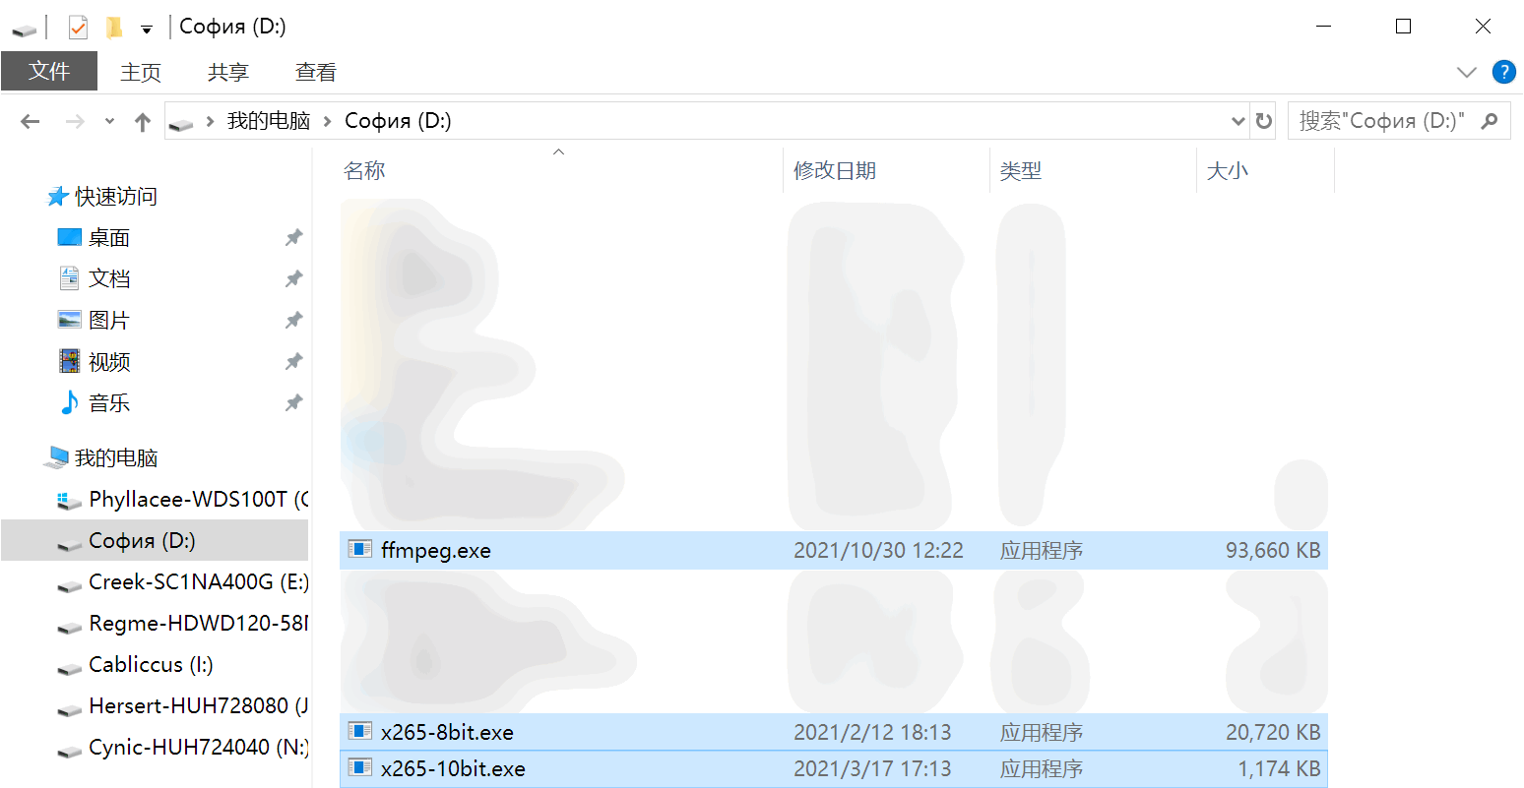

[Open Windows CMD/PowerShell or Linux/MacOS Bash/Terminal, write path & ffmpeg.exe, ffprobe.exe, x265.exe and enter; makesure all program exists]

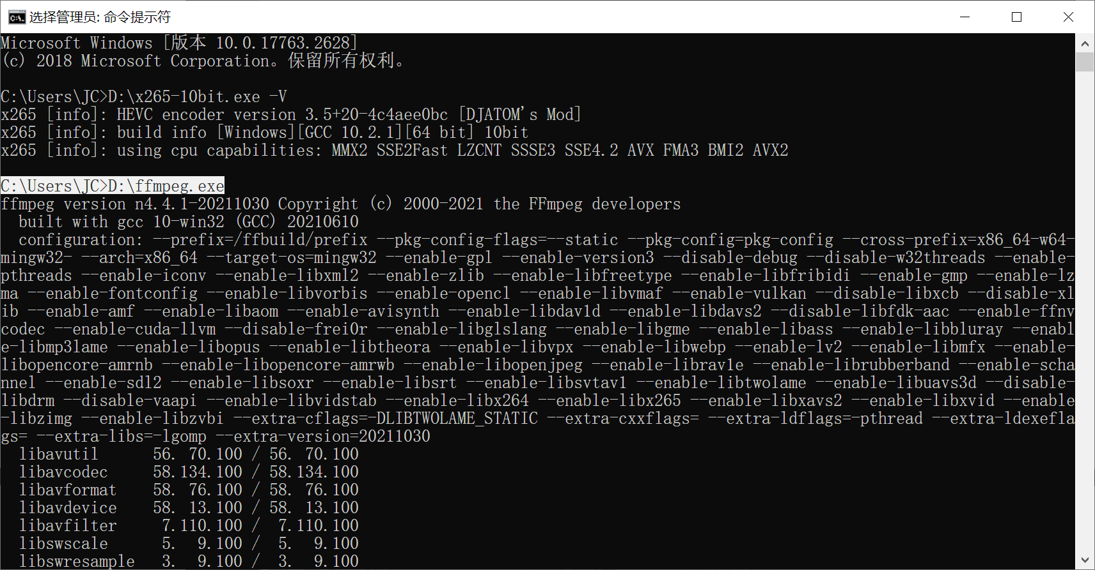[ffmpeg build ver.] ffmpeg.exe; [x265 build ver.] x265.exe -V

[CMD auto-filling] Write some portion of PATH/filename, and hit [Tab] will trigger auto-fill

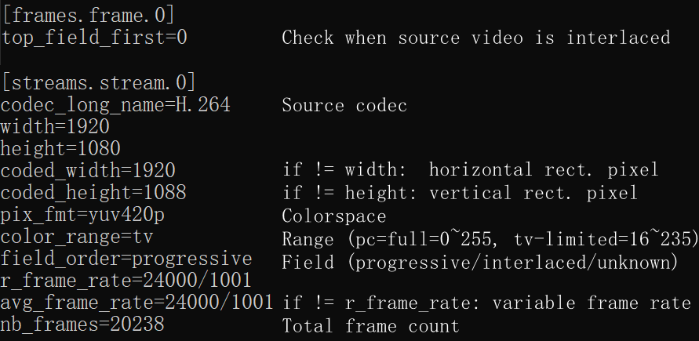[Gain source video info w/ ffprobe] ffprobe.exe -i ".\video.mp4" -select_streams v:0 -v error -hide_banner -show_streams -show_frames -read_intervals "%+#1" -show_entries frame=top_field_first:stream=codec_long_name,width,coded_width,height,coded_height,pix_fmt,color_range,field_order,r_frame_rate,avg_frame_rate,nb_frames -of ini

[interlaced] not a progressive video, check top/bottom field goes first & add x265 parameter --interlaced<tff/bff>

[variable frame rate] source used on mobile devices to save battery, causing compatibility issues. Add ffmpeg option -vsync cfr to convert to cfr

[rectangular pixel] old & unsupported lossy compression. Swap src video if possible

[encoding duration] nb_frames÷encoding speed (fps)=time(second)

[x265's required info] ffmpeg -pix_fmt<given by src video, similar as picture above>

[ffmpeg-pipe-x265 example] D:\ffmpeg.exe -i F:\video.mov -an -pix_fmt yuv420p10 -f yuv4mpegpipe -strict unofficial - | D:\x265-10bit.exe --preset slow --hist-scenecut --me umh --subme 5 --merange 48 --weightb --aq-mode 4 --bframes 5 --ref 3 --hash 2 --allow-non-conformance --qg-size 16 --rd 3 --limit-modes --limit-refs 1 --rskip 1 --splitrd-skip --no-sao --tskip --colorprim bt2020 --colormatrix bt2020nc --transfer smpte2084 --y4m - --output F:\done.hevc 2>D:\Desktop\ffmpeg_or_x265_error_logs.txt

### ffmpeg, VS, avs2yuv pipe

ffmpeg -i video_in.mp4 -an -f yuv4mpegpipe -strict unofficial - | x265 --y4m - --output

ffmpeg -i video_in.mp4 -an -f rawvideo - | x265.exe --input-res <WxH> --fps <int/flo/frac> - --output

-format, -an bypass audio, -strict unofficial lift std. restrictions, --y4m stands for "YUV for MPEG", both "-" passes stream through the Unix pipe

VSpipe.exe VSScript.vpy --y4m - | x265.exe - --y4m --output

VSpipe/avs2yuv VSScript.vpy - | x265.exe --input-res <WxH> --fps <int/flo/frac> - --output

avs2yuv.exe AVSScript.avs -raw - | x265.exe --input-res <WxH> --fps <int/flo/frac> - --output

**ffmpeg .ass subtitle rendering:** -filter_complex "ass='F\:/subtitle.ass'"

Stop encoding & mux encoded frames: Ctrl+C, exists in some people's x265 compile

**ffmpeg multiplex audio into video encap. (output file extension alters format)**

* ffmpeg.exe -i ".\video_stream.mp4" -an -c:v copy -i ".\audio_stream.aac" -c copy "multiplexed.mov"

**ffmpeg replace existing audio in video encap. (itoffset ±seconds to align new audio)**

* ffmpeg.exe -i ".\mux_in.mov" -i ".\new_ad_st_in.aac" -c:v copy -map 0:v:0 -map 1:a:0 -c:a copy -itsoffset 0 ".\new_mux_out.mov"

**ffmpeg built-in scaling**: -sws_flags bicubic bitexact gauss neighbor bicublin lanczos spline +full_chroma_int +full_chroma_inp +accurate_rnd

Example: -sws_flags bitexact+full_chroma_int+full_chroma_inp+accurate_rnd)

### HDR Tags

**Color**

**Primaries**

--master-display <manually tagging for instruct video players or decoders to correctly play HDR sources

DCI-P3: G(13250,34500)B(7500,3000)R(34000,16000)WP(15635,16450)L(?,1)

bt709: G(15000,30000)B(7500,3000)R(32000,16500)WP(15635,16450)L(?,1)

bt2020: G(8500,39850)B(6550,2300)R(35400,14600)WP(15635,16450)L(?,1)

* Check HDR source's metadata for color space，then copy the corresponding settings above as param value
* max for L has no standards，which means every video could be different, check your source stream

DCI-P3: G(x0.265, y0.690), B(x0.150, y0.060), R(x0.680, y0.320), WP(x0.3127, y0.329)

bt709: G(x0.30, y0.60), B(x0.150, y0.060), R(x0.640, y0.330), WP(x0.3127,y0.329)

bt2020: G(x0.170, y0.797), B(x0.131, y0.046), R(x0.708, y0.292), WP(x0.3127,y0.329)>

-- cll <same value as master-display max L>

--colormatrix <as src, e.g.: gbr bt709 fcc bt470bg smpte170m YCgCo bt2020nc bt2020c smpte2085 ictcp>

--transfer <as source, e.g.: gbr bt709 fcc bt470bg smpte170m YCgCo bt2020nc bt2020c smpte2085 ictcp>

# Encoding speed reference

**Processor:** R7 5800X all core 4.5Ghz w/ negative voltage auto-offset, 67°C under FC140, avg 15440pts under CbR23 (PBO2 4.85Ghz minus 30 curve offset, 86°C under FC140, only raises 2%, thus unused)

**RAM:** Hynix MFR 2×2R×8GB/2x16GB, 3000Mhz 15-17-17-35 1T 1.44V, F-U-MCLK 1:1:1 sync

**Source:** 1920x1080 yuv420p8 24000/1001fps 312MB low quality h.264 film source, high contrast texture complex foreground, static low contrast background, 20238 frames

**Method:** 10bit crf 28 to enhance depth error, low quality source reduces result difference, high contrast complex texture forces encoder to reduce skipping functions

**preset slow:** 16m 27s, avg~20.5fps, results in 217MB, visible quality loss (more visible in HQ source)

**Gen·Simple:** 24m 48s, avg~13.6fps, 1.5x slower than top, in 159MB, visible quality loss

**Anime·HC:** 36m 36s, avg~9.21fps, 2.2x slower than top, in 145MB, visible quality loss (film src)

**Film·HC:** 78m 57s, avg~4.27fps, 4.8x slower than top, in 189MB, very small loss

**veryslow:** 133m 16s, avg~2.53fps, 8.1x slower than top, in 221MB, very small loss

# Gen-Purpose·Simple·LQ

no more configurable options for simplicity, only a few fps slower than top

**splt-trans**

**me-mc**

**adpt quant**

**rate control**

**io**

**tgt. depth**

**multi node**

**others**

**colorspace**

--preset slow --hist-scenecut

--me umh --subme 5 --merange 48 --weightb

--aq-mode 4

--bframes 5 --ref 3

--hash 2 --allow-non-conformance

-D 8/10/12 (default 8bit or lowest built in x265.exe, same or convert to lower depth only w/ --dither)

--pools ,,,, (e.g.: "-,+"states PC w/ 2 nodes & use the 2nd only, using both nodes causes mem. delay)

crop: --display-window < integer "←,↑,→,↓" pixels >, ≥16 core cpu opt.:--pme, interlaced: --field, pixel depth reduction quality+:--dither, begin; ending frame:--seek; --frames, crf/abr resist noise factor:--rc-grain

ffmpeg -pix_fmt yuv420p / yuv422p / yuv444p / yuv420p10 / yuv422p10 / yuv444p10…

**(ffmpeg pipe) x265 CLI parameters**

* ffmpeg.exe -thread_queue_size 5000 -loglevel 16 -hwaccel auto -y -hide_banner -i ".\v_in.mp4" -an -f yuv4mpegpipe -pix_fmt<ffprobe pix_fmt> -strict unofficial - | x265.exe --preset slow --hist-scenecut --me umh --subme 5 --merange 48 --weightb --aq-mode 4 --bframes 5 --ref 3 --hash 2 --allow-non-conformance --y4m - --output ".\v_out.mp4"

**libx265 CLI, compatible w/ libav fork**

* ffmpeg.exe -thread_queue_size 5000 -loglevel 16 -hwaccel auto -y -hide_banner -i ".\v_in.mp4" -c:v libx265 -pix_fmt<ffprobe pix_fmt> -x265params "preset=slow:hist-scenecut=1:me=umh:subme=5:merange=48:weightb=1:bframes=5:ref=3:hash=2:allow-non-conformance=1" -c:a copy ".\v_out.mp4"

**libkvazaar CLI (in dev, crf mode missing) (libx265 ffmpeg CLI is lacking 85% of params, skipped)**

* ffmpeg.exe -thread_queue_size 5000 -loglevel 16 -hwaccel auto -y -hide_banner -i ".\v_in.mp4" -c:v libkvazaar -pix_fmt<ffprobe pix_fmt> -kvazaar-params "limit-tu=1:tr-depth-intra=2:pu-depth-intra=4:pu-depth-inter=3:smp=1:amp=1:bipred=1:me=tz:subme=4:merange=48:me-early-termination=off:max-merge=2:ref=3:open-gop=0:period=360:gop=16:transform-skip=1:qp=16:fast-residual-cost=1:early-skip=1:max-merge=4:rd=3:mv-rdo=1:rdoq-skip=1:intra-rdo-et=1:sao=edge:hash=checksum" -c:a copy ".\v_out.mp4"

# Customize·Standard.

Lots of custom options for optimizations

--tu-intra-depth 3 --tu-inter-depth 3 --limit-tu 1 --rdpenalty 1

--me umh --subme <24fps=3, 48fps=4, 60fps=5, 100fps=6> --merange 48 --weightb

--ref 3 --max-merge <2fast, 3, 4slow> --early-skip --no-open-gop --min-keyint 5 --keyint <9×fps> --fades --bframes 8 --b-adapt 2 --radl 3 <sharp source: --pbratio 1.2>

--hist-scenecut <fast: --fast-intra / mid: leave blank / slow: --b-intra / slower: --constrained-intra >

--crf <18~20 low loss 19 ~22 good> --crqpoffs -3 --cbqpoffs -1

--rdoq-level <1fast，2slow>

<anime source: --hevc-aq, remove aq-mode> --aq-mode 4 --aq-strength <flat=0.8, edgy=1>

--rd 3 --limit-modes --limit-refs 1 --rskip <3fast, 2mid, 1slow> --rc-lookahead <3×fps> --tskip-fast --rect <veryslow: --amp>

--psy-rd <film=1.6，anime=0.6, +0.6 if ctu=64, -0.6 if ctu=16> --splitrd-skip <EXP: --qp-adaptation-range 3>

--limit-sao --sao-non-deblock --deblock 0:-1

--hash 2 --allow-non-conformance <NAS streaming: --idr-recovery-sei>

-D 8/10/12 (default 8bit or lowest built in x265.exe, same or convert to lower depth only w/ --dither)

--pools ,,,, (e.g.: "-,+"states PC with 2 nodes & use the 2nd only, using both nodes causes mem. delay)

crop:--display-window < integer "←,↑,→,↓" pixels >, ≥16 core cpu opt.:--pme, interlaced: --field, pixel depth reduction quality+:--dither, begin; ending frame:--seek; --frames, crf/abr resist noise factor:--rc-grain

ffmpeg -pix_fmt yuv420p / yuv422p / yuv444p / yuv420p10 / yuv422p10 / yuv444p10…

**splt-trans**

**me-mc**

**ref-rateol**

**intra coding**

**quantization**

**rdoq**

**adapt quant**

**md decision**

**rdo**

**deblock-sao**

**io**

**tgt. depth**

**multi node**

**others**

**colorspace**

**(ffmpeg pipe) x265 CLI parameters**

* ffmpeg.exe -thread_queue_size 5000 -loglevel 16 -hwaccel auto -y -hide_banner -i ".\v_in.mp4" -an -f yuv4mpegpipe -strict unofficial -pix_fmt<ffprobe pix_fmt> - | x265.exe --ctu 〇 --min-cu-size 16 --tu-intra-depth 3 --tu-inter-depth 3 --limit-tu 1 --rdpenalty 1 --me umh --subme 〇 --merange 48 --weightb --ref 3 --max-merge 〇 --early-skip --no-open-gop --min-keyint 5 --fades --bframes 8 --b-adapt 2 --radl 3 --pbratio 1.2 --hist-scenecut --fast-intra --b-intra --constrained-intra --crf 〇 --crqpoffs -3 --crqpoffs -1 --rdoq-level 〇 --aq-mode 4 --aq-strength 〇 --rd 3 --limit-modes --limit-refs 1 --rskip 〇 --rc-lookahead 〇 --tskip-fast --rect --amp --psy-rd 〇 --splitrd-skip --qp-adaptation-range 4 --limit-sao --sao-non-deblock --deblock 0:-1 --hash 2 --allow-non-conformance --y4m - --output ".\v_out.mp4"

**libx265 CLI, compatible w/ libav fork**

* ffmpeg.exe -thread_queue_size 5000 -loglevel 16 -hwaccel auto -y -hide_banner -i ".\v_in.mp4" -c:v libx265 -pix_fmt<ffprobe pix_fmt> -x265params "ctu=〇:min-cu-size=16:tu-intra-depth=3:tu-inter-depth=3:limit-tu=1:rdpenalty=1:me=umh:subme=〇:merange=48:weightb=1:ref=3:max-merge=〇:early-skip=1:open-gop=0:min-keyint=5:fades=1:bframes=8:b-adapt=2:radl=3:pbratio=1.2:hist-scenecut=1:fast-intra=1:b-intra=1:constrained-intra=1:crf=〇:crqpoffs=-3:cbqpoffs=-1:rdoq-level=〇:aq-mode=4:aq-strength=〇:rd=3:limit-modes=1:limit-refs=1:rskip=〇:rc-lookahead=〇:tskip-fast=1:rect=1:amp=1:psy-rd=〇:splitrd-skip=1:qp-adaptation-range=4:limit-sao=1:sao-non-deblock=1:deblock=0:-1:hash=2:allow-non-conformance=1" -c:a copy ".\v_out.mp4"

High Compression·Film·HQ Source

--tu-intra-depth 4 --tu-inter-depth 4 --limit-tu 1

--me star --subme <24fps=3, 48fps=4, 60fps=5, 100fps=6> --merange 48 --weightb

--ref 3 --max-merge 4 --no-open-gop --min-keyint 3 --keyint 310 --fades --bframes 8 --b-adapt 2 --radl 3

--hist-scenecut --constrained-intra --b-intra

--crf 21.8 --qpmin 8 --crqpoffs -3 --ipratio 1.2 --pbratio 1.5

--rdoq-level 2

--aq-mode 4 --aq-strength <clean source=0.8，film=1> --qg-size 8

--rd 3 --limit-refs 0 --rskip 0 --rc-lookahead <1.8×fps> --rect --amp

--psy-rd <film=1.6, animation=0.6, +0.6 if ctu=64, -0.6 if ctu=16> <EXP: --qp-adaptation-range 3>

--deblock 0:0

--limit-sao --sao-non-deblock --selective-sao 3

--hash 2 --allow-non-conformance --nr-inter 8 <NAS streaming: --idr-recovery-sei>

-D 8/10/12 (default 8bit or lowest built in x265.exe, same or convert to lower depth only w/ --dither)

--pools ,,,, (e.g.: "-,+"states PC with 2 nodes & use the 2nd only, using both nodes causes mem. delay)

crop:--display-window < integer "←,↑,→,↓" pixels >, ≥16 core cpu opt.:--pme, interlaced: --field, pixel depth reduction quality+:--dither, begin; ending frame:--seek; --frames, crf/abr resist noise factor:--rc-grain

ffmpeg -pix_fmt yuv420p / yuv422p / yuv444p / yuv420p10 / yuv422p10 / yuv444p10…

**splt-trans**

**me-mc**

**ref-rateol**

**intra coding**

**quantization**

**rdoq**

**adapt.quant**

**md decision**

**rdo**

**deblock**

**sao**

**io**

**tgt. depth**

**multi node**

**others**

**colorspace**

**(ffmpeg pipe) x265 CLI parameters**

* ffmpeg.exe -thread_queue_size 5000 -loglevel 16 -hwaccel auto -y -hide_banner -i ".\v_in.mp4" -an -f yuv4mpegpipe -strict unofficial -pix_fmt<ffprobe pix_fmt> - | x265.exe --tu-intra-depth 4 --tu-inter-depth 4 --limit-tu 1 --me star --subme 〇 --merange 48 --weightb --ref 3 --max-merge 4 --no-open-gop --min-keyint 3 --keyint 310 --fades --bframes 8 --b-adapt 2 --radl 3 --hist-scenecut --constrained-intra --b-intra --crf 21.8 --qpmin 8 --crqpoffs -3 --ipratio 1.2 --pbratio 1.5 --rdoq-level 2 --aq-mode 4 --aq-strength 〇 --qg-size 8 --rd 3 --limit-refs 0 --rskip 0 --rc-lookahead 〇 --rect --amp --psy-rd 〇 --qp-adaptation-range 3 --deblock 0:0 --limit-sao --sao-non-deblock --selective-sao 3 --hash 2 --allow-non-conformance --y4m - --output ".\v_out.mp4"

**libx265 CLI, compatible w/ libav fork**

* ffmpeg.exe -thread_queue_size 5000 -loglevel 16 -hwaccel auto -y -hide_banner -i ".\v_in.mp4" -c:v libx265 -pix_fmt<ffprobe pix_fmt> -x265params "tu-intra-depth=4:tu-inter-depth=4:limit-tu=1:me=star:subme=〇:merange=48:weightb=1:ref=3:max-merge=4:open-gop=0:min-keyint=3:keyint=310:fades=1:bframes=8:b-adapt=2:radl=3:hist-scenecut=1:constrained-intra=1:b-intra=1:crf=21.8:qpmin=8:crqpoffs=-3:ipratio=1.2:pbratio=1.5:rdoq-level=2:aq-mode=4:aq-strength=〇:qg-size=8:rd=3:limit-refs=0:rskip=0:rc-lookahead=〇:rect=1:amp=1:psy-rd=〇:qp-adaptation-range=3:deblock=0:0:limit-sao=1:sao-non-deblock=1:selective-sao=3:hash=2:allow-non-conformance=1" -c:a copy ".\v_out.mp4"

Editing footage·Render & Reuse

--ctu 32

--me star --subme <24fps=3, 48fps=4, 60fps=5, 100fps=6> --merange 48 --analyze-src-pics

--max-merge 4 --early-skip --b-intra

--hist-scenecut --no-open-gop --min-keyint 1 --keyint <7×fps>--ref 3 --fades --bframes 7 --b-adapt 2

--crf 17 --crqpoffs -3 --cbqpoffs -2

--rd 3 --limit-modes --limit-refs 1 --rskip 1 --rc-lookahead <4×fps>

--splitrd-skip

--deblock -1:-1

--hash 2 --allow-non-conformance

--tune grain

-D 8/10/12

crop:--display-window < integer "←,↑,→,↓" pixels >, ≥16 core cpu opt.:--pme, interlaced: --field, pixel depth reduction quality+:--dither, begin; ending frame:--seek; --frames, crf/abr resist noise factor:--rc-grain, multi-node: --pools ,,,,

ffmpeg -pix_fmt yuv420p / yuv422p / yuv444p / yuv420p10 / yuv422p10 / yuv444p10…

**block/unit spitting**

**motion est.&cmp**

**.**

**intraframe search**

**rate control**

**quantization**

**mode decision**

**R-D optimization**

**deblock**

**input output**

**tuning**

**tgt pixel bit depth**

**others**

**colorspace**

**(ffmpeg pipe) x265 CLI parameters**

* ffmpeg.exe -thread_queue_size 5000 -loglevel 16 -hwaccel auto -y -hide_banner -i ".\v_in.mp4" -an -f yuv4mpegpipe -strict unofficial -pix_fmt<ffprobe pix_fmt> - | x265.exe --ctu 32 --me star --subme 〇 --merange 48 --analyze-src-pics --max-merge 4 --early-skip --b-intra --hist-scenecut --no-open-gop --min-keyint 1 --keyint 〇 --ref 3 --fades --bframes 7 --b-adapt 2 --crf 17 --crqpoffs -3 --cbqpoffs -2 --rd 3 --limit-modes --limit-refs 1 --rskip 1 --rc-lookahead 〇 --splitrd-skip --deblock -1:-1 --hash 2 --allow-non-conformance --tune grain --y4m - --output ".\v_out.mp4"

**libx265 CLI, compatible w/ libav fork**

* ffmpeg.exe -thread_queue_size 5000 -loglevel 16 -hwaccel auto -y -hide_banner -i ".\v_in.mp4" -c:v libx265 -pix_fmt<ffprobe pix_fmt> -x265params "ctu=32:me=star:subme=〇:merange=48:analyze-src-pics=1:max-merge=4:early-skip=1:hist-scenecut=1:open-gop=0:min-keyint=1:keyint=〇:ref=3:fades=1:bframes=7:b-adapt=2:radl=3:constrained-intra=1:b-intra=1:crf=17:crqpoffs =-3:cbqpoffs=-2:rd=3:limit-modes=1:limit-refs=1:rskip=1:rc-lookahead=〇:splitrd-skip=1:deblock=-1:-1:hash=2:allow-non-conformance=1:tune=grain" -c:a copy ".\v_out.mp4"

Anime·High Compression·Subtitle Groups

--tu-intra-depth 4 --tu-inter-depth 4 --max-tu-size 16

--me umh --merange 48 --subme <24fps=3, 48fps=4, 60fps=5, 100fps=6> --weightb <remove weightb for 80's anime that doesn't have lighting fades for performance> --max-merge 4 --early-skip

--ref 3 --no-open-gop --min-keyint 5 --keyint <12×fps> --fades --bframes 16 --b-adapt 2 --radl 3 --bframe-bias 20

--hist-scenecut --constrained-intra --b-intra

--crf 22 --crqpoffs -4 --cbqpoffs -2 --ipratio 1.6 --pbratio 1.3 --cu-lossless --tskip

--psy-rdoq 2.3 --rdoq-level 2

--hevc-aq --aq-strength 0.9 --qg-size 8

--rd 3 --limit-modes --limit-refs 1 --rskip 1 --rc-lookahead <2.5×fps> --rect --amp

--psy-rd 1.5 --splitrd-skip --rdpenalty 2 <EXP: --qp-adaptation-range 4>

--deblock 0:-1 --limit-sao --sao-non-deblock

--hash 2 --allow-non-conformance --single-sei <NAS streaming: --idr-recovery-sei>

-D 8/10/12 (default 8bit or lowest built in x265.exe, same or convert to lower depth only w/ --dither)

--pools ,,,, (e.g.: "-,+"states PC with 2 nodes & use the 2nd only, using both nodes causes mem. delay)

crop:--display-window < integer "←,↑,→,↓" pixels >, ≥16 core cpu opt.:--pme, interlaced: --field, pixel depth reduction quality+:--dither, begin; ending frame:--seek; --frames, crf/abr resist noise factor:--rc-grain

ffmpeg -pix_fmt yuv420p / yuv422p / yuv444p / yuv420p10 / yuv422p10 / yuv444p10…

**splt-trans**

**me-mc**

**ref-rateol**

**intra coding**

**quantization**

**rdoq**

**aq**

**md**

**rdo**

**deblock -sao**

**io**

**tgt. depth**

**multi nodes**

**others**

**colorspace**

**(ffmpeg pipe) x265 CLI parameters**

* ffmpeg.exe -thread_queue_size 5000 -loglevel 16 -hwaccel auto -y -hide_banner -i ".\v_in.mp4" -an -f yuv4mpegpipe -strict unofficial -pix_fmt<ffprobe pix_fmt> - | x265.exe --tu-intra-depth 4 --tu-inter-depth 4 --max-tu-size 16 --me umh --subme 〇 --merange 48 --weightb --max-merge 4 --early-skip --ref 3 --no-open-gop --min-keyint 5 --keyint 〇 --fades --bframes 16 --b-adapt 2 --radl 3 --bframe-bias 20 --hist-scenecut --constrained-intra --b-intra --crf 22 --crqpoffs -4 --cbqpoffs -2 --ipratio 1.6 --pbratio 1.3 --cu-lossless --tskip --psy-rdoq 2.3 --rdoq-level 2 --hevc-aq --aq-strength 0.9 --qg-size 8 --rd 3 --limit-modes --limit-refs 1 --rskip 1 --rc-lookahead 〇 --rect --amp --psy-rd 1.5 --splitrd-skip --rdpenalty 2 --qp-adaptation-range 4 --deblock -1:0 --limit-sao --sao-non-deblock --hash 2 --allow-non-conformance --single-sei --y4m - --output ".\v_out.mp4"

**libx265 CLI, compatible w/ libav fork**

* ffmpeg.exe -thread_queue_size 5000 -loglevel 16 -hwaccel auto -y -hide_banner -i ".\v_in.mp4" -c:v libx265 -pix_fmt<ffprobe pix_fmt> -x265params "tu-intra-depth=4:tu-inter-depth=4:max-tu-size=16:me=umh:subme=〇:merange=48:weightb=1:max-merge=4:early-skip=1:ref=3:open-gop=0:min-keyint=5:keyint=〇:fades=1:bframes=16:b-adapt=2:radl=3:bframe-bias=20:hist-scenecut=1:constrained-intra=1:b-intra=1:crf=22:crqpoffs=-4:cbqpoffs=-2:ipratio=1.6:pbratio=1.3:cu-lossless=1:tskip=1:psy-rdoq=2.3:rdoq-level=2:hevc-aq=1:aq-strength=0.9:qg-size=8:rd=3:limit-modes=1:limit-refs=1:rskip=1:rc-lookahead=〇:rect=1:amp=1:psy-rd=1.5:splitrd-skip=1:rdpenalty=2:qp-adaptation-range=4:deblock=-1:0:limit-sao=1:sao-non-deblock=1:hash=2:allow-non-conformance=1:single-sei=1" -c:a copy ".\v_out.mp4"

Anime·ripper's cold war·HEDT Only

Paused dark flat scenes must look AS-IS, results less & slower compression than sub grps

--tu-intra-depth 4 --tu-inter-depth 4 --max-tu-size 4 --limit-tu 1

--me star --subme <24fps=3, 48fps=4, 60fps=5, 100fps=6> --merange 52 --analyze-src-pics --weightb --max-merge 4

--ref 3 --no-open-gop --min-keyint 1 --keyint <12×fps> --fades --bframes 16 --b-adapt 2 --radl 2

--hist-scenecut --b-intra

--crf 17 --crqpoffs -5 --cbqpoffs -2 --ipratio 1.67 --pbratio 1.33

--cu-lossless

--psy-rdoq 2.5 --rdoq-level 2

--hevc-aq --aq-strength 1.4 --qg-size 8

--rd 5 --limit-refs 0 --rskip 0 --rc-lookahead <2.5×fps> --rect --amp --no-cutree

--psy-rd 1.5 --rdpenalty 2 <EXP: --qp-adaptation-range 5>

--deblock -2:-2

--limit-sao --sao-non-deblock --selective-sao 1

--hash 2 --allow-non-conformance --single-sei <NAS streaming: --idr-recovery-sei>

crop:--display-window < integer "←,↑,→,↓" pixels >, ≥16 core cpu opt.:--pme, interlaced: --field, pixel depth reduction quality+:--dither, begin; ending frame:--seek; --frames, crf/abr resist noise factor:--rc-grain, target depth: -D 8/10/12, multi-node: --pools ,,,,

**splt-trans**

**me-mc**

**ref-rateol**

**intra coding**

**quantization**

**lossless qnt**

**rdoq**

**aq**

**md**

**rdo**

**deblock**

**sao**

**io**

**others**

**(ffmpeg pipe) x265 CLI parameters**

* ffmpeg.exe -thread_queue_size 5000 -loglevel 16 -hwaccel auto -y -hide_banner -i ".\v_in.mp4" -an -f yuv4mpegpipe -strict unofficial -pix_fmt<ffprobe pix_fmt> - | x265.exe --tu-intra-depth 4 --tu-inter-depth 4 --max-tu-size 4 --limit-tu 1 --me star --subme 〇 --merange 52 --analyze-src-pics --weightb --max-merge 4 --ref 3 --no-open-gop --min-keyint 1 --keyint 〇 --fades --bframes 16 --b-adapt 2 --radl 2 --hist-scenecut --b-intra --crf 16 --crqpoffs -5 --cbqpoffs -2 --ipratio 1.67 --pbratio 1.33 --cu-lossless --psy-rdoq 2.5 --rdoq-level 2 --hevc-aq --aq-strength 1.4 --qg-size 8 --rd 5 --limit-refs 0 --rskip 0 --rc-lookahead 〇 --rect --amp --no-cutree --psy-rd 1.5 --rdpenalty 2 --qp-adaptation-range 5 --deblock -2:-2 --limit-sao --sao-non-deblock --selective-sao 1 --hash 2 --allow-non-conformance --single-sei --y4m - --output ".\v_out.mp4"

**libx265 CLI, compatible w/ libav fork**

* ffmpeg.exe -thread_queue_size 5000 -loglevel 16 -hwaccel auto -y -hide_banner -i ".\v_in.mp4" -c:v libx265 -pix_fmt<ffprobe pix_fmt> -x265params "tu-intra-depth=4:tu-inter-depth=4:max-tu-size=4:limit-tu=1:me=star:subme=〇:merange=52:analyze-src-pics=1:weightb=1:max-merge=4:mcstf=1:ref=3:open-gop=0:min-keyint=1:keyint=〇:fades=1:bframes=16:b-adapt=2:radl=2:hist-scenecut=1:b-intra=1:crf=16:crqpoffs=-5:cbqpoffs=-2:ipratio=1.6:pbratio=1.33:cu-lossless=1:psy-rdoq=2.5:rdoq-level=2:hevc-aq=1:aq-strength=1.4:qg-size=8:rd=5:limit-refs=0:rskip=0:rc-lookahead=〇:rect=1:amp=1:cutree=0:psy-rd=1.5:rdpenalty=2:qp-adaptation-range=5:deblock=-2:-2:limit-sao=1:sao-non-deblock=1:selective-sao=1:hash=2:allow-non-conformance=1:single-sei=1" -c:a copy ".\v_out.mp4"